Zhang Zhang

1.

1. Regression problem
2. Classification problem

2.

a.

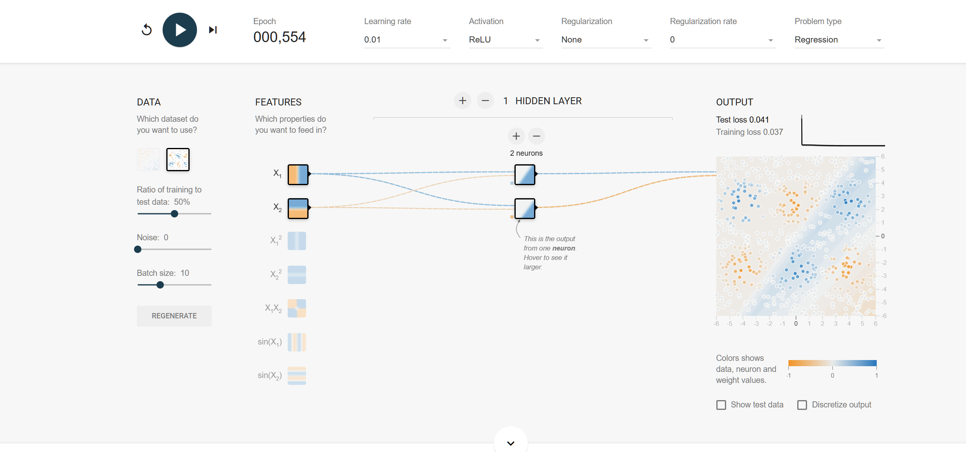

b.

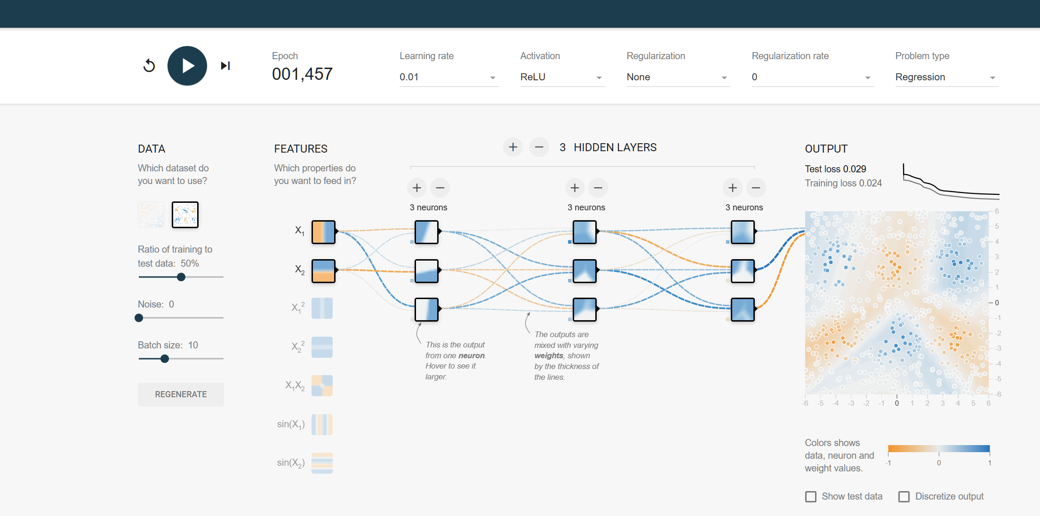

c.

3.

C, as the gradient decent points towards the optimum on the contour.

4.

a.

Using 1-neighbor classifier, the test point belongs to the black group.

b.

Using 3- neighbor classifier, the test point belongs to the red group.